**Task 17**

**Launch a t2.micro instance in Mumbai region where ssh can be done only from your IP address with docker and docker-compose installed in it.**

**Creating t2. Micro instance**

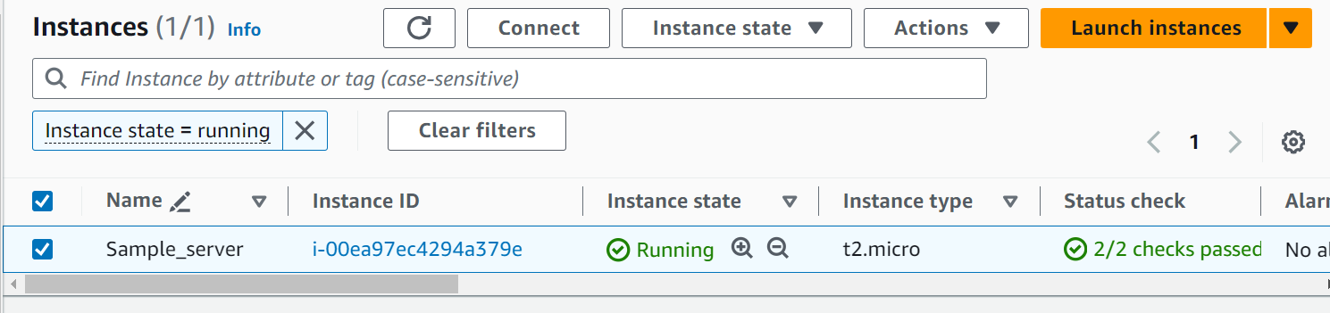

**Installing docker and docker compose**

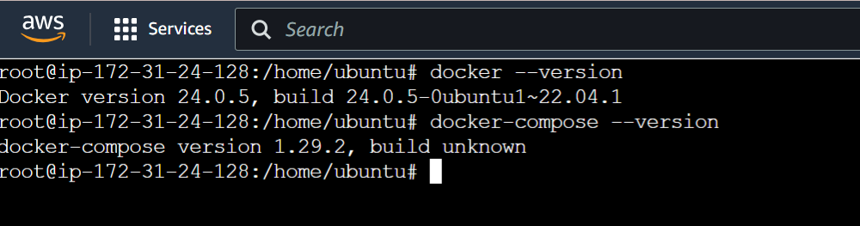

**Selecting My IP**

